|  |  |  |
| --- | --- | --- |
| **Name of Student: Pushkar Sane** | | |
| **Roll Number: 45** | | **Lab Assignment Number: 8** |
| **Title of Lab Assignment: Exception Handling with Spring boot.** | | |
| **DOP: 28-10-2023** | | **DOS: 30-10-2023** |
| **CO Mapped:**  **CO5, CO6** | **PO Mapped:**  **PO1, PO2, PO3, PO4, PO7, PSO1, PSO2** | **Signature:** |

**Practical No. 8**

**Aim:**

1. To implement a program to demonstrate Number Format Exception: Enter Roll No, Name, Marks and Subject from command line and calculate percentage.

**File Structure:**

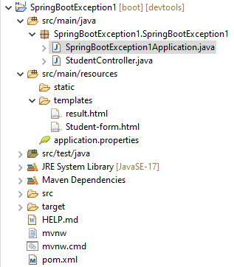

**Code:**

**SpringBootException1Application.java**

package SpringBootException1.SpringBootException1;

import org.springframework.boot.SpringApplication;

import org.springframework.boot.autoconfigure.SpringBootApplication;

@SpringBootApplication

public class SpringBootException1Application {

public static void main(String[] args) {

SpringApplication.run(SpringBootException1Application.class, args);

}

}

**StudentController.java**

package SpringBootException1.SpringBootException1;

import org.springframework.stereotype.Controller;

import org.springframework.ui.Model;

import org.springframework.web.bind.annotation.GetMapping;

import org.springframework.web.bind.annotation.PostMapping;

import org.springframework.web.bind.annotation.RequestParam;

@Controller

public class StudentController {

@GetMapping("/calculate")

public String showForm() {

return "student-form";

}

@PostMapping("/calculate")

public String ShowResult(@RequestParam String rollNo, @RequestParam String name, @RequestParam String subject,

@RequestParam String marks, Model model) throws NumberFormatException {

try {

double mark = Double.parseDouble(marks);

double percentage = (mark / 100) * 100;

model.addAttribute("name", name);

model.addAttribute("rollNo", rollNo);

model.addAttribute("subject", subject);

model.addAttribute("marks", marks);

model.addAttribute("percentage", percentage);

return "result";

} catch (NumberFormatException ex) {

model.addAttribute("error", "Invalid marks entered");

return "student-form";

}

}

}

**result.html**

<!DOCTYPE html>

<html xmlns:th="http://www.thymeleaf.org">

<head>

<title>Result</title>

</head>

<body>

<h2>Student Information</h2>

<p>Roll No: <span th:text="${rollNo}"></span></p>

<p>Name: <span th:text="${name}"></span></p>

<p>Marks: <span th:text="${marks}"></span></p>

<p>Subject: <span th:text="${subject}"></span></p>

<p>Percentage: <span th:text="${percentage}"></span>%</p>

</body>

</html>

**Student-form.html**

<!DOCTYPE html>

<html xmlns:th="http://www.thymeleaf.org">

<head>

<title>Calculate Percentage</title>

</head>

<body>

<h2>Enter Student Information</h2>

<form action="/calculate" method="post">

Roll No: <input type="text" name="rollNo" required /><br><br>

Name: <input type="text" name="name" required /><br><br>

Marks: <input type="text" name="marks" required /><br><br>

Subject: <input type="text" name="subject" required /><br><br>

<button type="submit">Calculate Percentage</button>

</form>

<p th:text="${error}" style="color: red;"></p>

</body>

</html>

**pom.xml**

<?xml version="1.0" encoding="UTF-8"?>

<project xmlns="http://maven.apache.org/POM/4.0.0"

xmlns:xsi="http://www.w3.org/2001/XMLSchema-instance"

xsi:schemaLocation="http://maven.apache.org/POM/4.0.0 https://maven.apache.org/xsd/maven-4.0.0.xsd">

<modelVersion>4.0.0</modelVersion>

<parent>

<groupId>org.springframework.boot</groupId>

<artifactId>spring-boot-starter-parent</artifactId>

<version>3.1.5</version>

<relativePath /> <!-- lookup parent from repository -->

</parent>

<groupId>SpringBootException1</groupId>

<artifactId>SpringBootException1</artifactId>

<version>0.0.1-SNAPSHOT</version>

<name>SpringBootException1</name>

<description>Exception handling</description>

<properties>

<java.version>17</java.version>

</properties>

<dependencies>

<dependency>

<groupId>org.springframework.boot</groupId>

<artifactId>spring-boot-starter-web</artifactId>

</dependency>

<dependency>

<groupId>org.springframework.boot</groupId>

<artifactId>spring-boot-starter-test</artifactId>

<scope>test</scope>

</dependency>

<dependency>

<groupId>org.springframework.boot</groupId>

<artifactId>spring-boot-starter-thymeleaf</artifactId>

</dependency>

<dependency>

<groupId>org.springframework.boot</groupId>

<artifactId>spring-boot-devtools</artifactId>

</dependency>

</dependencies>

<build>

<plugins>

<plugin>

<groupId>org.springframework.boot</groupId>

<artifactId>spring-boot-maven-plugin</artifactId>

</plugin>

</plugins>

</build>

</project>

**Output:**

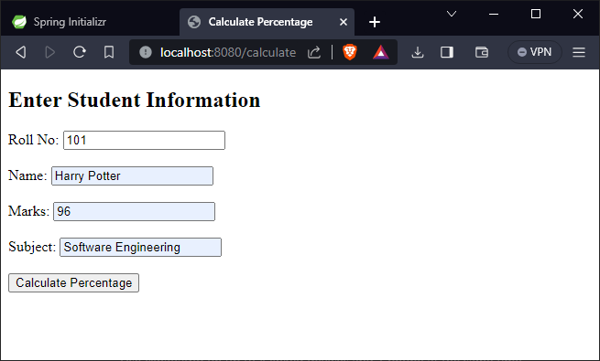

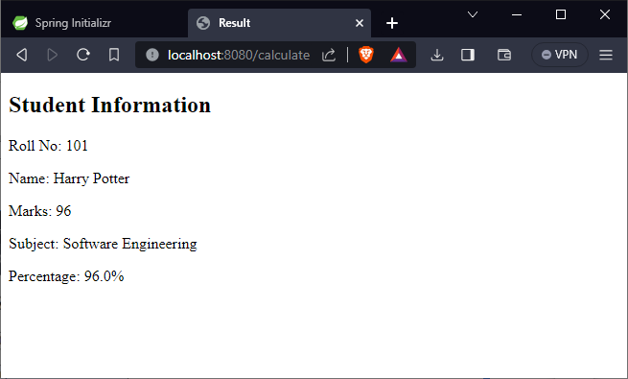

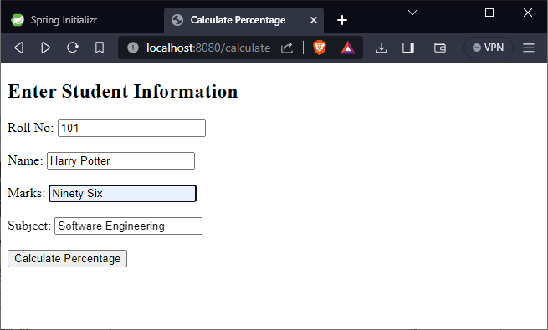

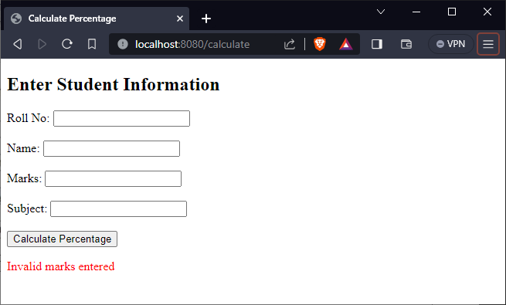

1. To implement a program to create user defined exceptions. Create class Bank and define methods open (), deposit() and withdraw() with minimum balance 500. Create an exception Payout of bounds and fire except.

**File Structure:**

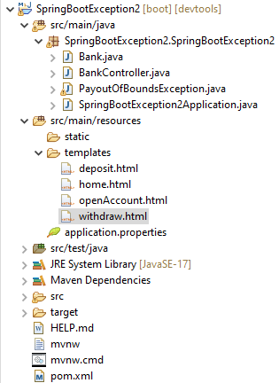

**Code:**

**Bank.java**

package SpringBootException2.SpringBootException2;

public class Bank {

private int amount;

final int min = 500;

String name;

public Bank(int amt, String name) {

this.amount = amt;

this.name = name;

}

public void Withdraw(int amt) throws PayoutOfBoundsException {

if (amount - min < amt)

throw new PayoutOfBoundsException("Withdrawal not allowed. Minimum balance limit is 500.");

else

amount -= amt;

}

public void deposit(int amt) {

this.amount += amt;

}

public int getAmount() {

return amount;

}

public String getName() {

return name;

}

}

**BankController.java**

package SpringBootException2.SpringBootException2;

import org.springframework.stereotype.Controller;

import org.springframework.ui.Model;

import org.springframework.web.bind.annotation.GetMapping;

import org.springframework.web.bind.annotation.PostMapping;

import org.springframework.web.bind.annotation.RequestParam;

@Controller

public class BankController {

Bank bank;

@GetMapping("/openAccount")

public String openAccount() {

return "openAccount";

}

@PostMapping("/home")

public String StartAccount(@RequestParam int amount, @RequestParam String name, Model model) {

bank = new Bank(amount, name);

model.addAttribute("amount", amount);

model.addAttribute("name", name);

return "home";

}

@GetMapping("home")

public String updatedHome(Model model) {

model.addAttribute("amount", bank.getAmount());

model.addAttribute("name", bank.getName());

return "home";

}

@PostMapping("/deposit")

public String DepositMoney(@RequestParam int amount, Model model) {

bank.deposit(amount);

model.addAttribute("message", "Deposit successful.");

return "deposit";

}

@PostMapping("/withdraw")

public String WithdrawMoney(@RequestParam int amount, Model model) {

try {

bank.Withdraw(amount);

model.addAttribute("message", "Withdraw successful.");

} catch (Exception e) {

model.addAttribute("error", e.getMessage());

}

return "withdraw";

}

@GetMapping("/deposit")

public String depositForm() {

return "deposit";

}

@GetMapping("/withdraw")

public String withdrawForm() {

return "withdraw";

}

}

**PayoutOfBoundsException.java**

package SpringBootException2.SpringBootException2;

public class PayoutOfBoundsException extends RuntimeException {

public PayoutOfBoundsException(String message) {

super(message);

}

}

**SpringBootException2Application.java**

package SpringBootException2.SpringBootException2;

import org.springframework.boot.SpringApplication;

@SpringBootApplication

public class SpringBootException2Application {

public static void main(String[] args) {

SpringApplication.run(SpringBootException2Application.class, args);

}

}

**deposit.html**

<!DOCTYPE html>

<html>

<head>

<title>Deposit</title>

</head>

<body>

<h1>Deposit Money</h1>

<form method="post" action="/deposit">

<input type="text" name="amount" placeholder="Amount">

<button type="submit">Deposit</button>

</form>

<p th:text="${message}" style="color: green;"></p>

<br>

<a href="/home">Home</a>

</body>

</html>

**home.html**

<!DOCTYPE html>

<html xmlns:th="http://www.thymeleaf.org">

<head>

<title>Welcome to SBI</title>

</head>

<body>

<h2>Welcome to SBI</h2>

<p>Account Holder : <span th:text="${name}"></span></p>

<p>Account Balance : <span th:text="${amount}"></span></p>

<a href="/withdraw">Withdraw</a>

<br>

<a href="/deposit">Deposit</a>

</body>

</html>

**openAccount.html**

<!DOCTYPE html>

<html xmlns:th="http://www.thymeleaf.org">

<head>

<title>Open Bank Account</title>

</head>

<body>

<h2>Open Bank Account</h2>

<form action="/home" method="post">

Enter Name : <input type="text" required name="name" /> <br><br>

Enter Amount : <input type="text" required name="amount" /> <br><br>

<button type="submit">Open Account</button>

</form>

</body>

</html>

**withdraw.html**

<html>

<head>

<title>Withdraw</title>

</head>

<body>

<h1>Withdraw Money</h1>

<form method="post" action="/withdraw">

<input type="text" name="amount" placeholder="Amount">

<button type="submit">Withdraw</button>

</form>

<p th:text="${error}" style="color: red;"></p>

<p th:text="${message}" style="color: green;"></p>

<br>

<a href="/home">Home</a>

</body>

</html>

**pom.xml**

<?xml version="1.0" encoding="UTF-8"?>

<project xmlns="http://maven.apache.org/POM/4.0.0"

xmlns:xsi="http://www.w3.org/2001/XMLSchema-instance"

xsi:schemaLocation="http://maven.apache.org/POM/4.0.0 https://maven.apache.org/xsd/maven-4.0.0.xsd">

<modelVersion>4.0.0</modelVersion>

<parent>

<groupId>org.springframework.boot</groupId>

<artifactId>spring-boot-starter-parent</artifactId>

<version>3.1.5</version>

<relativePath /> <!-- lookup parent from repository -->

</parent>

<groupId>SpringBootException2</groupId>

<artifactId>SpringBootException2</artifactId>

<version>0.0.1-SNAPSHOT</version>

<name>SpringBootException2</name>

<description>Demo project for Spring Boot</description>

<properties>

<java.version>17</java.version>

</properties>

<dependencies>

<dependency>

<groupId>org.springframework.boot</groupId>

<artifactId>spring-boot-starter-thymeleaf</artifactId>

</dependency>

<dependency>

<groupId>org.springframework.boot</groupId>

<artifactId>spring-boot-starter-web</artifactId>

</dependency>

<dependency>

<groupId>org.springframework.boot</groupId>

<artifactId>spring-boot-devtools</artifactId>

<scope>runtime</scope>

<optional>true</optional>

</dependency>

<dependency>

<groupId>org.springframework.boot</groupId>

<artifactId>spring-boot-starter-test</artifactId>

<scope>test</scope>

</dependency>

</dependencies>

<build>

<plugins>

<plugin>

<groupId>org.springframework.boot</groupId>

<artifactId>spring-boot-maven-plugin</artifactId>

</plugin>

</plugins>

</build>

</project>

**Output:**

